User Manual

Employee Management Program

(DMC Corp)

Table of Content

1. Searching for existing employees _______________________3
2. View wages record of existing__________________________4
3. Update Employee Information and View wages record of existing employee____________________________________5
4. Submitting new employee information___________________6
5. Inhiation of the program

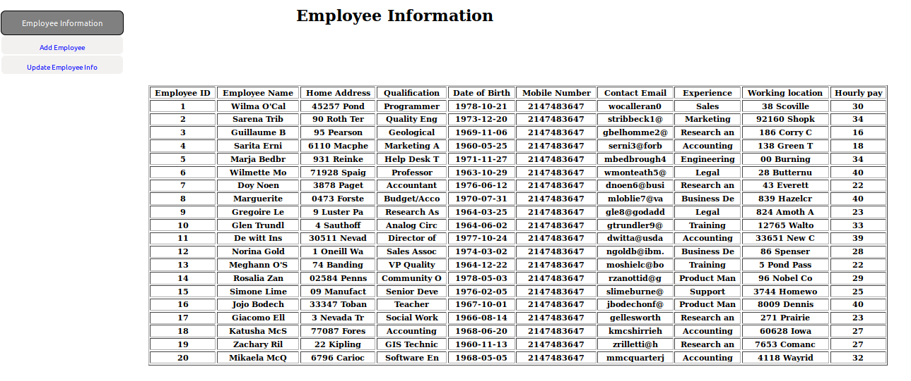

To transition to the add employee page, click the “add employee” button

1. 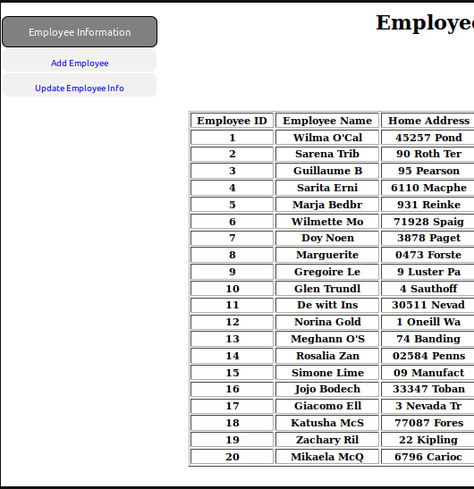Searching for Existing Employees

To search and update existing employee, click the “update Employee Info” button. (Image from 1. Initiation of the program).

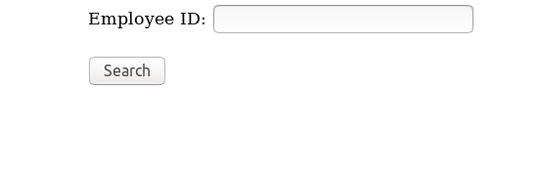

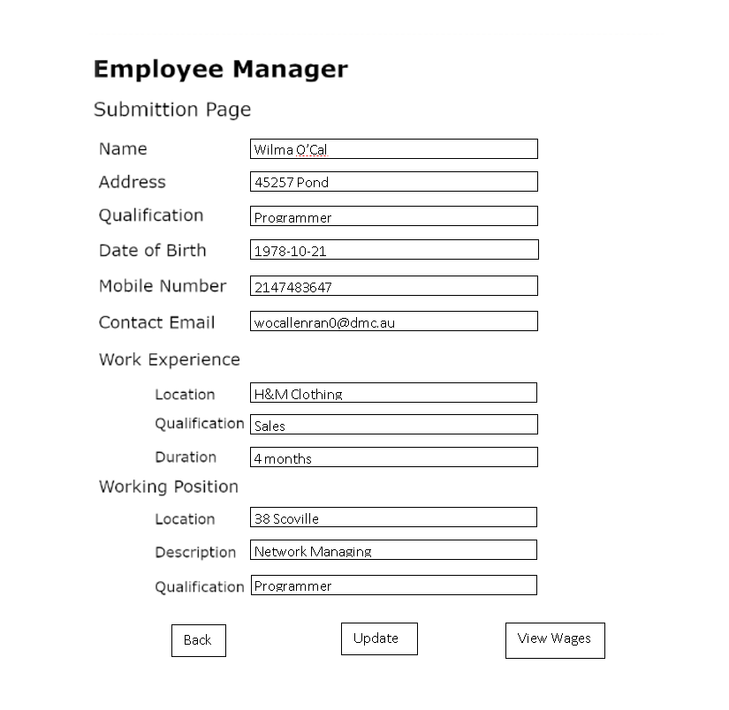

Click search to proceed to the information form. If the employee ID is correct and the search is successful, a form should appear with all information of the employee

1. Update Employee Information and View wages record of existing employee



After a successful search, the information page will appear with the view wages button. To view the wage records, click the “View Wages” button. After transitioning to the wage record, the form should look like this.

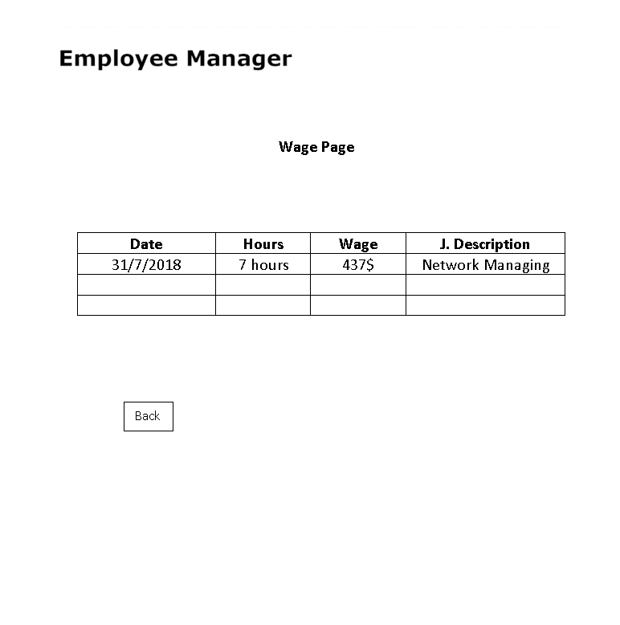

To move back to the submission page. Click the “back” button.

After modifying the employee information, click “update” button to update the information of the employee on the database

1. Submitting New Employee Information

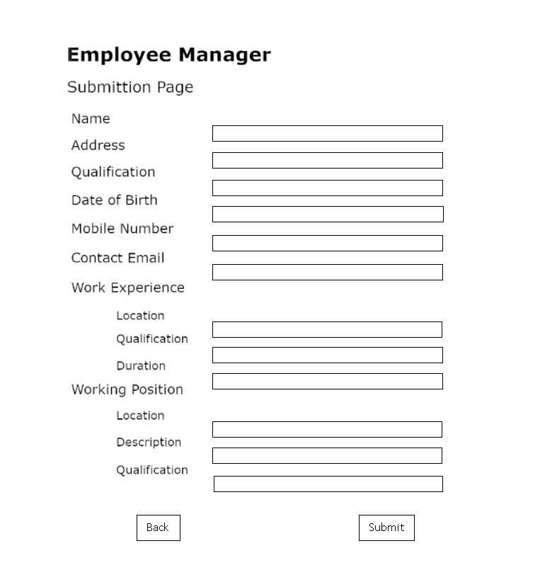

All fields must be filled for the submission to proceed due to legal responsibilities

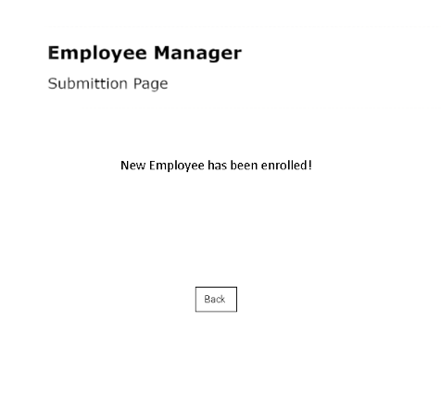

After filling all the new information, click the submit bottom. If the submission is successful, a form should appear say that it has.

Thanks for using the product! Hope you enjoy it!

Evaluation

An Employee management system was developed for the owner of DMC Corp to organise employee information, employee’s pay and their working position. The system was created to reduce the confusion within the HR (Human Resources) Management. The business was using email and online cloud storage to distribute information to employees. Information of employees are kept in an excel sheet which is hard to navigate and search for certain employee/information as it is cramped within the sheet. As preferred in the user manual, new employee’s information can be added within the database and existing employee information can also be viewed within the new database, including the pay record.

User Interface Design

In the initiation of the program, a form showing all employees with all the function provided on the left-hand side.



As mentioned before, the business stores their information within a excel spreadsheet, therefore the information is poorly presented due to the presence of other information over lapping with it. In this new design, the information is clearly presented within the form which increase the ease of use for the business HR manager. The form is created to be simple and informative as it will be used in a working and professional manner. In the submission page bellow, to search for an employee, the user must provide the form with a name to search for her/his information. All information must be filled to submit a new employee due to legal issues that the organisation must keep a clear and thorough record of any employees.



The code bellow is used to submit a new employee into the database. A new employee ID will be automatically generated as the new employee information is submitted as can be seen from the code.

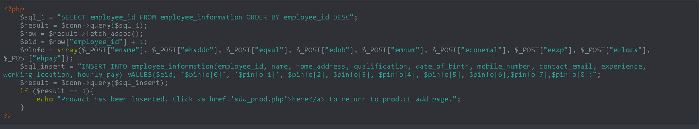

When the new employee information is fully filled and submitted, the form will change into a new form with a message saying that it is successful and a “back” button will be provided for the user to move back to the original form.

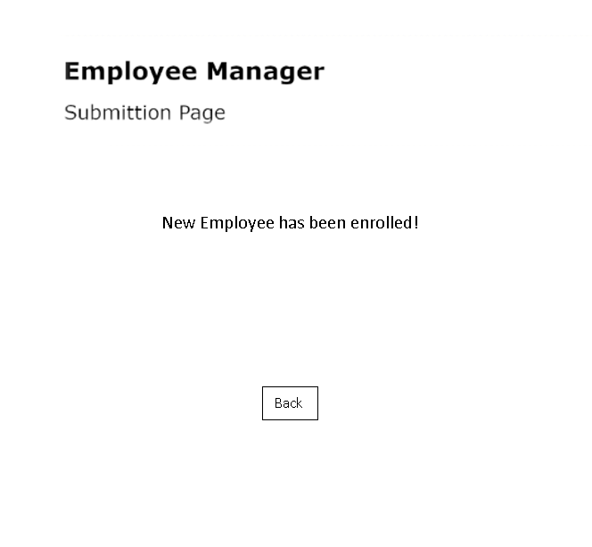

As the user search for a certain employee, the table will be filled with the employee information including the “view wage” button to transition to the wage record of the employee. A “back” button was also added if the user looked for the wrong employee.





The command bellows execute the update process as the “Update” button has been pressed. Each unique row will be updated as intended.

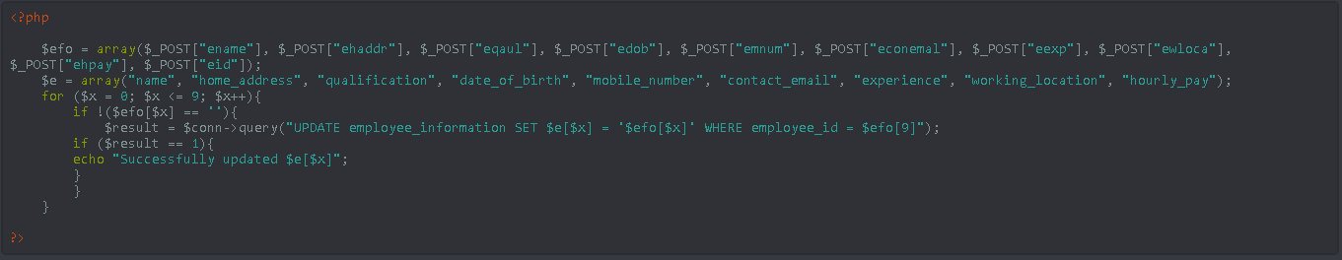

The wage page was created to be clear and simple for the user’s ease of use. It shows the all the information needed for the wage of the employee. A “back” button was added for the user to travel back to the employee information form. The table on the page can also be edited if the user has the authority as an admin. The back button will also serve as a save button as the user travel back.



\

Recommendation

Throughout the implementation of the project, there are many mistakes that has been made, therefore, improvements are crucial for projects with the same goal turn out to be better than this project. There should be more forms and functionality within the forms, for example, more buttons with more functions should be added for the ease of use for the user, however, not too many should be added as it can be cramped, annoying for the user to control the product. Furthermore, more constraints should be implemented through out the process of implementation for no mistakes that can be made as the user operates the product. Furthermore, it is crucial that time management between stages of the project should be improved to produce the best material in the line of work. In the future, a delete command should be added as well as the user may want to delete an employee information.