CONG TY CO PHAN TU VAN VA DAU TU DANG MINH
Huong dan cai dat chuong trinh ke toan

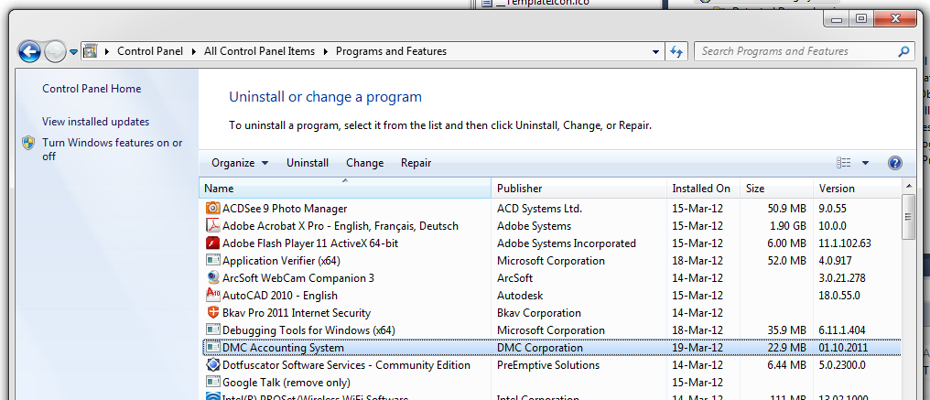
- Buoc 1: Truong hop chuong trinh da duoc cai dat, can thiet phai go bo Version cu
Vao: Control Panel/Program and Feature Hoac Control Panel/Add Remove Program
Bam Uninstall

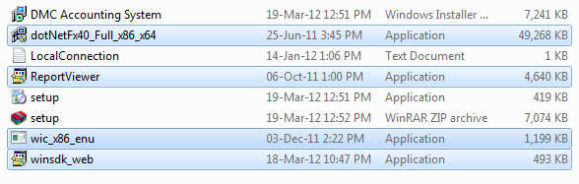
- Buoc 2: Cai day chuong trinh voi Version moi Hoac cai moi
- Trong thu muc cai dat luon co 5 file thu vien va 1 file Setup:
- Cac file thu vien can cai dat truoc khi cai dat chuong trinh ( Khi da cai 1 lan roi thi khong can cai laic ac thu vien duoi day nua ma qua thang buoc 3)
- Win_x86_enu : Cai nang cap doi voi Win XP Service Pakage 1
- dotNetFx40_Full_x86_x64 : Cai Dat thu vien DotNet 4.0 Frame Work cho Window
- ReportViewer : Thu Vien In An Report cho Chuong trinh
- Truong Hop Su Dung Win7 SP1 Can Cai them
- winsdk_web : Thu Vien bo sung cho Win7 SP1
- Buoc 3: Sauk hi cai dat xong Win_x86_enu, Dot Net Frame Work 4.0, ReportViewer,… Tien hanh cai dat chuong trinh ke toan chinh bang file : Setup.
Trong truong hop may tinh co noi mang Internet, Chuong trinh se tu dong download v acai dat cho .net Frame Work 4.0
- Buoc 4: Khi chay chuong trinh lan dau, Co the gap cac loi sau:
- Loi ket noi databse do chua co file: Localconnection, Truong hop nay giai quyet nhu sau:
- Tiep tuc bam ok de chuong trinh chay tiep, chuong trinh se tu dong cai dat file Localconnection
- Copy File LocalConnection vao thu muc cai dat:
  - C:\Program Files (x86)\DMC Corporation\DMC Accounting System
  - Hoac C:\Program Files \DMC Corporation\DMC Accounting System
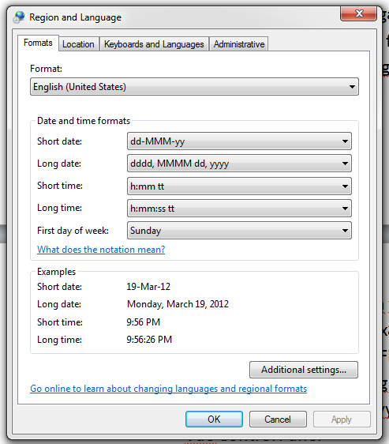
- Loi ve format ngay thang trong Window: Chuong trinh yeu cau format dang dd/mm/yyy ma trong Win goc ngay thang dat dang mm/dd/yyy nen can cai dat lai. Giai quyet nhu sau:
- Vao Control Panel
- Chon Region And Language
- Chon the Formats
- Chon lai nhu sau:

- Buoc 5: Cai Dat Thanh Cong

